Phone Simulator Project Documentation

Introduction
The Phone Simulator Project is an interactive graphical application developed in C++ using the SFML (Simple and Fast Multimedia Library) framework. The purpose of this project is to emulate a simplified smartphone environment within a desktop window. The simulator includes multiple fully functional mini‑applications such as a Calculator, Snake Game, Calendar, and Notepad. Each feature has been implemented with graphical components, event-driven programming, and modular functions to ensure clarity, maintainability, and expandability.

The design philosophy behind this project focuses on real-time rendering, interactive user interfaces, and the integration of multiple independent modules working cohesively within a single parent program. The project demonstrates knowledge of graphics programming, input processing, window management, file handling, and structured program design.

Header Files Used
The following header files were utilized throughout the project:

1. <SFML/Graphics.hpp>
- Core SFML header providing access to rendering, textures, sprites, fonts, shapes, and events.
- Used extensively across all modules for GUI display, window creation, and input detection.

2. <iostream>
- Used for console-based debugging and error output.

3. <ctime>
- Provides system time functionality, used for the clock display on the phone home screen.

4. <fstream>
- Used in the Notepad application to read and write text files.

5. <string> and <vector>
- Used for storing labels, text input, resource paths, and dynamic arrays.

Classes and Data Structures Used
Although the project does not define custom C++ classes, it makes heavy use of SFML classes as well as custom structs for game logic.

SFML Classes:

1. sf::RenderWindow
- Represents a window capable of receiving events and displaying graphics.
- Used for the main phone interface and for each separate application window.

2. sf::Texture
- Stores image data loaded from files.
- Used for app icons, backgrounds, and UI graphics.

3. sf::Sprite
- A drawable object representing a texture.
- Used to render app icons and background images.

4. sf::Font and sf::Text
- Used to load and display text such as time, calculator numbers, score, and calendar labels.

5. sf::RectangleShape
- Used to create shapes such as calculator buttons, snake segments, apple shapes, and calendar boxes.

6. sf::Event
- Handles user inputs including keyboard, mouse movement, mouse clicks, and text entered events.

7. sf::Clock
- Provides time measurement for controlling the snake’s movement speed.

User-Defined Structs:

1. struct Apple
- Stores x and y coordinates of the apple in the snake game.

2. struct Snake
- Stores x and y positions of each segment of the snake.

Global Variables
1. snakeSize
- Tracks current length of the snake.

2. score
- Holds current score in the snake game.

3. Directions enum
- Represents possible movement directions: UP, DOWN, LEFT, RIGHT.

4. gameOver
- Boolean flag signaling snake game termination.

5. Snake array
- Stores up to 100 snake segments.

6. Apple struct
- Stores apple position.

Functions Used
1. gettime()
- Retrieves current system time and formats it as HH:MM:SS AM/PM.

2. calculator()
- Implements the calculator application window, GUI, button logic, and arithmetic operations.

3. snakeGame()
- Implements classic snake game logic including movement, apple detection, growth, wrapping, and collision.

4. calendar()
- Loads current system date and generates a graphical calendar layout with highlighted current day.

5. notepad()
- Implements a text editor that loads saved notes, accepts typed characters, and writes content to file.

6. move()
- Internal function used by snakeGame() to advance the snake based on current direction.

7. main()
- Controls home screen, UI rendering, event polling, icon interaction, and app launching.

Detailed Working of Each Module
1. Home Screen
- Displays phone wallpaper using sf::Sprite.
- Time text centered dynamically using bounding box calculations.
- Four app icons drawn using textures.
- Hover effect implemented by changing sprite color.
- Mouse click detection used to launch apps via an array of function pointers.

2. Calculator App
- Creates a separate window and draws a 4x4 grid of buttons.
- Each button is an sf::RectangleShape labeled with sf::Text.
- Numerical and operator input handled using mouse click detection.
- stoi() used to convert digit strings to integers when performing arithmetic.
- Clear button resets input, equals button computes result using switch-case.

3. Snake Game
- Uses a grid-based logic system.
- snake[] array shifts positions from tail to head each frame.
- sf::Clock controls movement speed.
- Apples spawn randomly; snake grows upon consuming them.
- Screen wrapping ensures snake never leaves boundaries.
- Collision with self triggers game reset.

4. Calendar App
- Uses <ctime> to determine month, year, current day.
- Calculates first weekday using mktime().
- Draws 7 header boxes for Sun–Sat.
- Draws 42 day boxes for 6 weeks.
- Highlights current day with a different color.

5. Notepad App
- Reads previous notes from file notepadFile.txt.
- Captures typed characters using TextEntered event.
- Handles backspace and newline.
- Automatically wraps line after 44 characters.
- Saves updated note when window closes.

User Interface Description

The user interface has been designed to be intuitive and easy to navigate. The phone home screen acts as a central hub, where users can visually identify apps using icons. Hover effects provide immediate feedback to the user. Each application window uses its own layout and color theme:
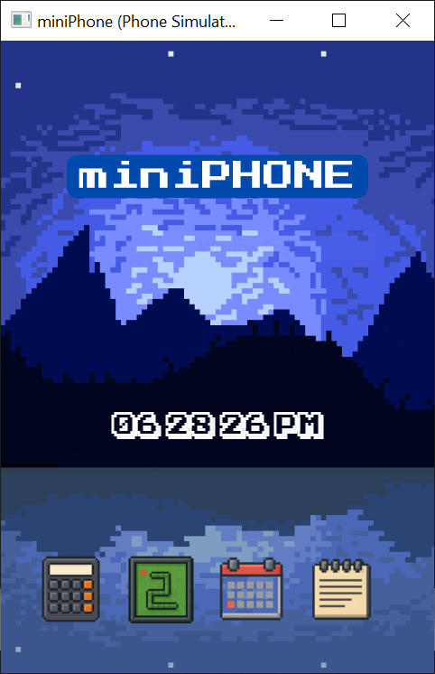

• Calculator uses a bold blue color scheme with clear numeric labels.
• Snake game uses minimalistic graphics to emphasize gameplay.
• Calendar uses boxed grids and contrasting colors for clarity.
• Notepad uses plain black text over a light background for readability.

Conclusion
The Phone Simulator Project successfully integrates multiple independent applications into a single, interactive environment. The use of SFML enables advanced graphical rendering and input handling, while modular structure ensures maintainability and readability. Each application demonstrates different aspects of C++ programming—from real‑time gameplay logic in the snake game to file handling in the notepad and GUI creation in the calculator. Overall, the project showcases strong understanding of event-driven programming, window management, graphics handling, and structured program design.

